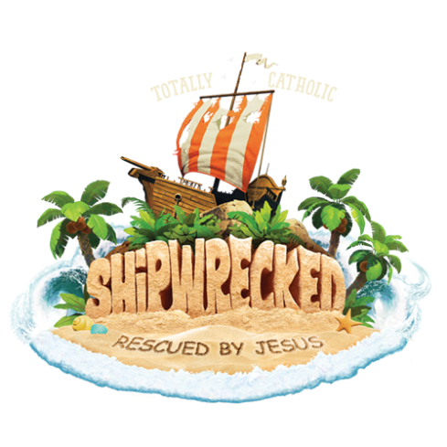
Recyclables Needed:
1 gallon plastic jugs
Tan-colored plastic grocery bags (i.e. Publix grocery bags)
Cardboard Boxes (broken down – large & extra large sizes)
Glass bottles (opening to hold small-end of an egg)

If you happen to have….(donate or lend for VBS decorating):
All kinds of Rope…. Any kind and length – and a really long one for Tug of War game!
Throw Blankets or Picnic-size mats
Old umbrellas
Old-Fashioned Suitcase/Foot Locker/Trunks
Old Locks/Antiques
Nautical décor (i.e. Fishing Nets, Anchor, Life Ring, Life Vest)
Faux jewels (oversized ideal (for treasure chest)
Artificial greenery, flowers, trees (any kind, but palm and bamboo #1)
Chair stool (approx. 3’ 4’ – not too high)
Overhead Projector
Pipe and Drape system for 6’x8” fabric hanging

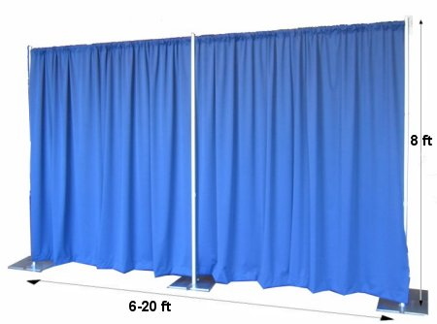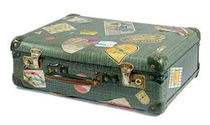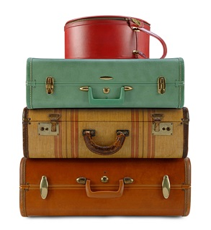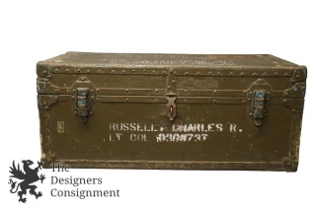

Please drop-off in Ministries Building or Contact: Patty Taylor (321) 961-4847.

